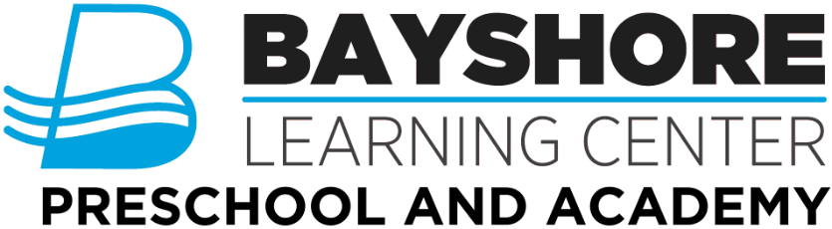
2022-2023 School Supplies
Supplies can be delivered at Meet the Teacher or the first day of school
All items MUST be labeled with child’s name
Infant’s Class
- 2 containers of wipes
- 2 boxes of gloves
- Bottles/Non-Leaking cup
- 2 changes of clothes to be kept at school
- Backpack or Diaper Bag
- Lunchbox with cold pack
- 2 boxes of facial tissue
- 2 rolls of paper towels
- 1 bottle of liquid hand soap
- Diapers to be kept in child’s personal cubby
- Water bottles (12 or 24 pack)
- You may bring extra formula, snacks, and baby food to be kept in your child’s cubby
- We do have refrigerators in the classroom, they are small and only used for bottles made and breast milk
One’s/Transitions Class
- School box (plastic, for crayons/markers, etc)
- 2 boxes of gloves
- 1 box crayons (not jumbo size)
- Non-Leaking Cup (no bottles in this classroom)
- Blanket for cot
- Lunchbox with cold pack (provide utensils)
- 2 containers baby wipes
- 1” white binder
- 2 changes of clothes to be kept at school
- 2 boxes of facial tissue
- 2 rolls paper towels
- 1 bottle of liquid hand soap
- 1 bottle of hand sanitizer
- Diapers to be kept in child’s personal cubby
- Water bottles (12 or 24 pack)
- We do have refrigerators in the classroom, they are too small for lunches. They will only hold cold snacks and drinks.
- Small Backpack (folder size)
Two’s Class
- School box (plastic, for crayons/markers, etc)
- 2 boxes of gloves
- 1 box crayons (not jumbo size)
- 1 set water colors
- 2 bottles white school glue
- 2 glue sticks
- 2 containers baby wipes
- 1” white binder
- 2 changes of clothes to be kept at school
- 1 ream of copy paper
- 2 boxes facial tissue
- 2 rolls paper towels
- 1 bottle of liquid hand soap
- 1 bottle of hand sanitizer
- Lunch box and cold pack (provide utensils)
- Non-Spill cup for water
- We do have refrigerators in the classroom, they are too small for lunches. They will only hold cold snacks and drinks.
- Blanket for cot
- Water bottles (12 or 24 pack)
- Small backpack (folder size)

Pre-K 3 & 4’s Class
- School box (plastic, for crayons/markers, etc)
- 1 box crayons (not jumbo size)
- 1 pair Fiskars scissors
- 1 box 10 count markers (not jumbo size)
- 1 set water colors
- 2 bottles white school glue
- 2 glue sticks
- 2 containers baby wipes
- 1” white binder
- 2 changes of clothes to be kept at school
- 1 ream of copy paper
- 2 boxes facial tissue
- 2 rolls paper towels
- 1 bottle of liquid hand soap
- 1 bottle of hand sanitizer
- Lunch box and cold pack (provide utensils)
- Non-Spill cup for water
- We do have refrigerators in the classroom, they are too small for lunches. They will only hold cold snacks and drinks.
- Blanket for cot
- Water bottles (12 or 24 pack)
- Small backpack (folder size)

**We are always in need of cleaning supplies. Any donations of bleach, Clorox/Lysol Wipes, Microban, sanitizer, gloves, paper towels or laundry detergent are greatly appreciated.**

